AIM: comparison of classification algorithms (KNN and Naïve Bayes)

DATASET USED:
Breast Cancer Detaction, it includes 569 rows and 17 columns
such as ID, Diagnosis, Radius Mean, Texture Mean, etc.

CODE:
import numpy as np
import pandas as pd
import matplotlib.pyplot as plt
import seaborn as sns
sns.set()
from sklearn.preprocessing import StandardScaler
from sklearn.neighbors import KNeighborsClassifier
from sklearn.model_selection import train_test_split, GridSearchCV
from sklearn.metrics import accuracy_score, recall_score, precision_score, confusion_matrix

Sorting the data
df = pd.read_csv("data.csv", index_col = 'id')
df.drop('Unnamed: 32',axis = 1 ,inplace = True)
df['diagnosis'] = df['diagnosis'].map({'M': 1, 'B':0})
X = df.drop('diagnosis',axis = 1)
perimeters = [x for x in df.columns if 'perimeter' in x]
areas = [x for x in df.columns if 'area' in x]
df.drop(perimeters, axis = 1 ,inplace = True)
df.drop(areas, axis = 1 ,inplace = True)
worst = [col for col in df.columns if col.endswith('_worst')]
df.drop(worst, axis = 1 ,inplace = True)
df

KNN
y = df['diagnosis']
X = df.drop(['diagnosis'], axis=1).values
X_scaled= StandardScaler().fit_transform(X)

#Define k-NN classifier and train on a scaled dataset#
knn = KNeighborsClassifier(n_neighbors=10)
knn.fit(X_scaled, y)
(algorithm='auto', leaf_size=30, metric='minkowski',
metric_params=None, n_jobs=None, n_neighbors=10, p=2,weights='uniform')
knn_params = {'n_neighbors': range(1, 11), 'weights':['uniform', 'distance']}

knn_params = {'n_neighbors': range(1, 11), 'weights':['uniform', 'distance']}
X_scaled_train, X_scaled_holdout, y_train, y_holdout = train_test_split(X_scaled, y, test_size=0.3, random_state=17)
#knn_grid.best_estimator_.predict(X_scaled_train)
knn_grid = GridSearchCV(knn, knn_params, cv=10, n_jobs=-1, scoring='recall')
knn_grid.fit(X_scaled_train, y_train)
knn_grid.best_params_, knn_grid.best_score_
({'n_neighbors': 1, 'weights': 'uniform'}, 0.9341666666666667)

pred = knn_grid.best_estimator_.predict(X_scaled_holdout)
print ("Accuracy Score : ",accuracy_score(y_holdout, pred))
print ("Recall Score (how much of malignant tumours were predicted correctly) : ",recall_score(y_holdout, pred) )
print ("Precision Score (how much of tumours, which were predicted as 'malignant', were actually 'malignant'): ",precision_score(y_holdout, pred))
Accuracy Score : 0.9181286549707602
Recall Score (how much of malignant tumours were predicted correctly) : 0.9180327868852459
Precision Score (how much of tumours, which were predicted as 'malignant', were actually 'malignant'): 0.8615384615384616
cm = confusion_matrix(y_holdout, pred)
cm
array([[101, 9],
[ 5, 56]])

Naïve Bayes
#Import Gaussian Naive Bayes model
from sklearn.naive_bayes import GaussianNB

#Create a Gaussian Classifier
gnb = GaussianNB()
#Train the model using the training sets
gnb.fit(X_scaled_train,y_train)

#Predict the response for test dataset
y_pred = gnb.predict(X_scaled_holdout)
#Import scikit-learn metrics module for accuracy calculation
from sklearn import metrics

# Model Accuracy, how often is the classifier correct?
print("Accuracy:",metrics.accuracy_score(y_holdout, y_pred))
print ("Recall Score (how much of malignant tumours were predicted correctly) : ",recall_score(y_holdout, y_pred) )
print ("Precision Score (how much of tumours, which were predicted as 'malignant', were actually 'malignant'): ",precision_score(y_holdout, y_pred))
Accuracy: 0.9415204678362573
Recall Score (how much of malignant tumours were predicted correctly) : 0.9016393442622951
Precision Score (how much of tumours, which were predicted as 'malignant', were actually 'malignant'): 0.9322033898305084
INNOVATIVE IDEA:
we can compare score on train an test sets for different number of neighbors:
from sklearn.model_selection import cross_val_score

test_scores = []
train_scores = []

for i in range(1,15):

knn = KNeighborsClassifier(i)
train_scores.append(cross_val_score(knn, X_scaled_train,y_train,cv=10, scoring='recall').mean())
test_scores.append(cross_val_score(knn, X_scaled_holdout,y_holdout,cv=10, scoring='recall').mean())

plt.figure(figsize=(12,5))
p = sns.lineplot(range(1,15),train_scores,marker='*',label='Train Score')
p = sns.lineplot(range(1,15),test_scores,marker='o',label='Test Score')
plt.xlabel("Neighbours")
plt.ylabel("Recall")
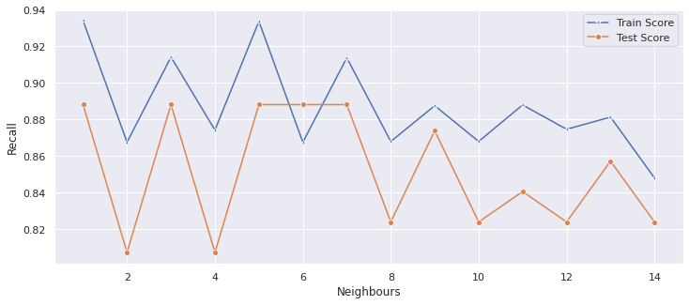

CONCLUSION:
We can conclude that Naïve Bayes have slightly imporved the accuracy and precision scores.

